Name | Zhou Wenyong | sex | Male | Date of Birth |  |  |  | May 1983 | 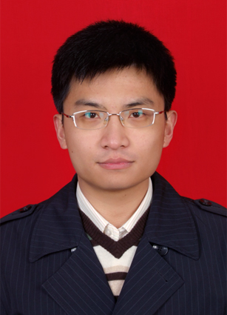
Average Score-Point | Enrollment in Sep 2012 | Major | Thoracic Surgery |  | Education |  |  | PhD
Political state | C.P.C | People | Han |  | Native place |  |  | Hohhot, Inner Mongolia
Tel | 15821673400 | E-mail | 123zwy@tongji.edu.cn
Address | No 1601-1, 28 Tie Ling Rd, Yangpu District, Shanghai |  |  |  |  | Post code | 200092
Education background | Admitted to tongji university school of medicine for graduate study in september 2009.  Graduated and obtained a master's degree in July 2012.  Exemption into the tongji university school of medicine for chest Doctoral graduate
Social and academic activities | Participate in The 10 of the Chinese Medical Association National Conference of Thoracic and Cardiovascular Surgery, and for the General Assembly  Participate in The14th National Assembly of Clinical Oncology, 2011 CSCO Annual Meeting
Research work | Completed National Natural Science Foundation “ Epithelial-Mesenchymal Transition-Related miRNA Identification and Function of Lung Cancer”.  As the main person in charge to complete Wu Jieping Fund “ EGFR Mutations and Epithelial–Mesenchymal Transition in Primary Lung Adenocarcino and Corresponding Mediastinal Lymph Node Metastases”  “Interferon-b efﬁciently inhibited endothelial progenitor cell-induced tumor angiogenesis” First author Gene Therapy. Impact Factor 4.538  “ Transforming growth factor-β1 promotes lung adenocarcinoma invasion and metastasis by epithelial to mesenchymal transition” Molecular and Cellular Biochemistry. Impact Factor 2.168  “ Transforming growth factor-b1 induces epithelial to mesenchymal transition in human lung cancer cells via PI3K/Akt and MEK/Erk1/2 signaling pathways” Mol Bio Rep 1.875  “Case report for surgical treatment of pulmonary artery sarcoma associated with lung cancer” Journal of Thoracic and Cardiovascular Surgery. First author  “ Off-pump surgical treatment for unilateral chronic pulmonary embolism” Clinical Pulmonary Medicine. First author  “Case report: liver abscess ruptured bile duct bronchial fistula” Journal of General Surgery. First author  “Video-assisted thoracic surgery lobectomy versus open lobectomy for unexpected pathologic N2 non-small cell lung cancer” Chinese Journal of Surgery. First author
Scholarships and Awards | Provincial “Outstanding student leaders”  Colonel-level “Outstanding student leaders”(Twice)
Foreign  Language skills | CET 4 and CET 6 passed  Good at English listening and speaking, directly to read the relevant professional foreign literature.
Computer abilities | Proficiency in a variety of common office software.  Proficient in common statistical software such as SPSS, SAS

